Skill Level: Beginner to Intermediate
Length: Full Day
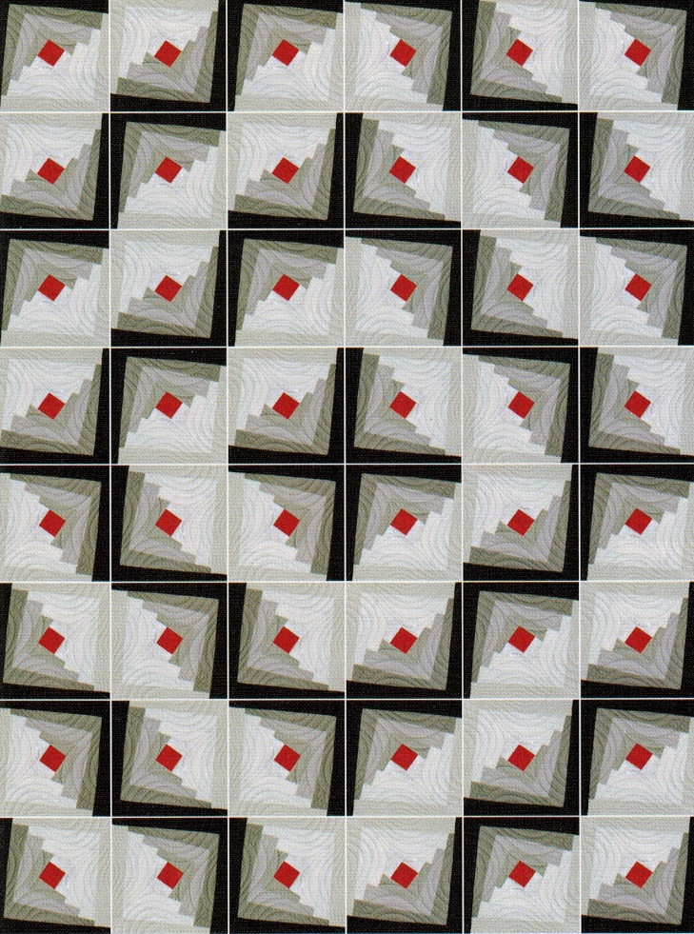 | This quilt adds a new twist on the traditional Log Cabin. Using four light colored fabrics, four dark colored fabrics and a center block, you’ll create a block with a variety of looks depending on layout and fabric selections.  This class is designed for the beginning to intermediate quilter.  Depending on your sewing experience, you may be able to finish three 12” quilt blocks in this full day class.  A kit is available (see Supply List below).
A sewing machine in good working order is a must for this class. Ideally, you are familiar with the machine basics. Please bring your power cord, presser foot, ¼” foot, extension cord, user’s manual and extra bobbins.
Supply List
Quilt in a Day, Twisted Log Cabin pattern  (includes 2 ½” Wonky Log Cabin Ruler) | These items are available in a kit for $60, or you can provide them yourself.  Quilt in a Day, Twisted Log Cabin pattern and Ruler, Quilt in a Day 6” Square Up Ruler, and enough fabric to make three 12” blocks (perfect for a table runner).  Contact instructor by May 31, 2018, to reserve a kit.  Lori Scandura  928-600-3482  quiltingteacher@suddenlink.net
Quilt in a Day, 6” Square Up Ruler
Fabric for Quilt Top:
- Please read pages 4 and 5 of the Quilt in a Day Twisted Log Cabin pattern and buy according to the size quilt you desire.

45 mm Rotary Cutter, with Replacement Blades | Provide these items yourself.
6 ½” x 24 ½” Rotary Cutting Ruler
Small Cutting Mat
Thread to match your fabric (Aurofill)
Stiletto
Sewing Machine Needles (Microtex 80/12)
4” Sharp Trimming Scissors
Straight Pins
Pencil and Notepad

